**Date:23-Jul-2020 Topic: Course Content**

Java Realtime Project Online Training

-------------------------------------

Batch Code : 11-JRTP

Pre-Requisites

---------------

Core Java

(OOPS, Collections, Exception Handling, Multi Threading, Annotations & Generics)

Adv Java (JDBC, Servlets & JSP)

Frameworks (ORM Basics, Spring IOC, Spring MVC)

Oracle (SQL)

Course Content

--------------

Part-1 : Industry Terminology & Industry Process

Part-2 : Realtime Tools (25+ Tools)

Part-3 : Mini Projects Development with Realtime standards

Part-4 : Major Project

Part-5: Interview Guide

Daily Timing : 11:30 AM to 1 PM IST

Duration : 90 Days (Monday - Saturday)

**Date:24-Jul-2020 Topic: Types Of software Companies**

Today' session : 11-JRTP First Class

-------------------------------------

Software Industry

-----------------

In Software industry 3 types of companies

1) Product Based Companies

2) Service Based Companies

3) Outsourcing Companies

What is Product Based Company?

------------------------------

The company which develops a project/product and sells that in market is called as Product Based Company.

Ex : MicroSoft, IBM, Sony, Samsung, Amazon etc....

What is Interview Process in Product Based Companies?

-----------------------------------------------------

1) System Test (Coding Test) Hacker Ranker/Hacker Earth

2) Data Structures & Algorithms

3) Design Patterns

4) System Design

5) Problem Solving

Package : For 3 years experience Amazon providing 18+ Lakhs

What is Service Based Company

------------------------------

These companies will develop Projects according to client requirements.

Ex: TCS, Infosys, Tech M, Wipro, HCL, CTS, Capgemini, Deloitte...

Interview Process

-----------------

1) System Test (Coding Test)

2) Technical Round - 1

3) Technical Round - 2

4) Project Manager

5) Client Interview

Package Structure : Year.Of Exp * 3 Lakhs

Outsourcing Companies

---------------------

These companies will recruite people for project requirement once that project is completed they will remove the people from company.

These companies will provide contract jobs

C 2 H (Contact to Hire) - 6 months

Ex : Magna Infotech, Source One Management etc...

**Date: 25-Jul-2020 Topic: Types Of Jobs &Types Of Project**

Today's session : Types of Jobs & Types of Projects

-------------------------------------------------------

Software companies are divided into 3 types

1) Product based

2) Service based

3) Outsourcing

Types of Jobs

-------------

1) Permanent Job

2) Contact Job

You got JOB in TCS company directley (Permanent Job)

----------------------------------------------------

Offer letter

Salary

PF

Health Insurance

Benefits

Your Will develop project in TCS

Contract Jobs

------------

You got job in Tech M through Magna InfoTech

Magna InfoTech -> Your Payroll Company

--------------------------------------

Offer letter

salary

payslips

Tech M --> Your client company

-------------------------------

Project you will do in Tech M

Types of Projects

-----------------

What is Project?

----------------

Collection software programs we can call as one Software Project.

Why we need to develop project?

------------------------------

To reduce human efforts

Ex: Ticket Booking, Net Banking, Food delivery etc...

How Many Types of Projects are available in IT industry?

-------------------------------------------------------

Software Projects we can divide into 3 types

1) Scratch development projects

2) Maintenence projects

3) Migration Projects

What is Scratch Development?

----------------------------

The project which is getting developed from beginning is called as scratch development project.

These kind of projects are less in industry

Note : If you are part of Scratch Development Project in company you are lucky bcz lot of learning scope will be available.

Maintenence Projects

--------------------

-> Maintenence Projects are also called as Support Projects

-> In Maintenence Projects we can see below types of works

a) Change Request (CR)

b) Enhancements

c) Bug Fixing (Production Support)

What is Change Request?

-----------------------

-> Client will ask to change existing functionality of the screen in project

-> Existing functionaity in the project we need to change as per client requirement.

What is Enhancement?

---------------------

Adding new functionality in existing project is called as Enhancement.

What is Bug fixing?

------------------

When project is using by clients/end users, we may get some exceptions. We have to fix them.

-> Bug fixing also called as Production Support

Migration Projects

------------------

-> Changing the project from one technology to another technology

Ex : Mainframes ----> Java

**Date: 27-Jul-2020 Topic: Project Teams Types**

Types of Teams in Project

--------------------------

1) Onshore Team

2) Offshore Team

What is Onshore Team?

---------------------

The team which is working in client location is called as Onshore Team.

What is Offshore Team?

----------------------

The team which is working in non-client location is called as Offshore team.

-> In On-Shore Functional Team members will be available (Functional Team also called as BA team)

-> Functional Team members are responsible to collect Requirements from Client.

-> After Collecting Requirements from client, Functional team members will prepare Business Requirements Document (BRD) and will share with Offshore Team members.

- BRD (Business Requirements Document)

- SRS (Software Requirements Specification)

- FDD (Functional Design Document)

-> In Offshore we will have below teams

> Developement Team

> Testing Team

> Database Team

> DevOps Team

-> Onshore and Offshore team members will communicate through Bridge calls to discuss project related details.

-> Companies will use softwares for Bridge calls

1) Microsoft Teams

2) Jabber with WebEx

3) Skype Business etc.....

-> Sometimes offshore team member will go onshore location as per client requirement. It is called as Onsite Opportunity

-> Onshore team member will come to offshore location to explain project requirements to offshore team members. It is called Offsite.

**Date: 30-Jul-2020 Topic: OverView Of Realtime Tools**

Q-1) What is the purpose of Realtime tools?

-----------------------------------------

Relatime tools will help the team members to complete work quickly and they will help us in maintaining the project for long time.

Q-2) What are the tools we should know As a Developer?

-----------------------------------------------------

1) Build Tools : These tools will help us in creating project structure, downloading dependencies, compiling source code, execute unit test cases, package our application and deploy our application.

Ex : Maven & Gradle

2) Version Control Tools : By using these tools, we can integrate and monitor source code developed by multiple team members in a project.

-> Version Control Software tools are also called as Software Configuration Management Tools.

Ex: SVN, Git Hub and BitBucket etc.

3) Unit Testing Tools: Unit testing helps us in identifying mistakes while coidng. With the help of Unit Testing we will provide quality code to higher environments.

Ex : Junit

4) Mocking Tools : Mocking is the process of create substitute for real object. In Unit Testing we will use Mocking.

Ex : Easy Mock, Power Mock, Wire Mock etc...

5) Code Coverage Tools : These tools will help us in identifying unit test execution details. These tools will help us in improving unit test scenarios

Ex : Jacoco

6) Logging: By using logging we can get the application execution detail in Runtime.

Ex : SLF4J, Log4J, Log4J2, Logback and Logstash....

7) Log Monitoring Tools : These tools will helps to get logs msgs available in log files.

Ex: Putty, WinScp and Splunk (recommended)

9) Code Review Tools : Helps us in identifying mistakes in code related to coding standars.

Ex : PMD and SonarQube

10) Deployment Tools : Once our functionality implementation completed, we have to deploy our code in a centralized server.

Ex : Jenkins

11) API Testing tools : To test webservices and Restful services

we need tools.

Ex : SOAP UI & POSTMAN

12) Project Management Tool : To manage project related work

Ex : JIRA

13) Containerization tools : To simply applicaton deployment in multiple environments

Ex : Docker

14) Memory Analyzer Tool : To analyze heap dump and thread dump

Ex : MAT

15) Performance Testing Tool : JMETER

**Date: 31-Jul-2020 Topic: Build Tools**

Agenda

--------

What is Build Tool?

Why we need build tool?

What are the build tools available?

Which tools are currently using in industry?

Working with Maven

Maven Repositories

- Central Repo

- Remote Repo

- Local Repo

Standalone app using maven

Maven Folder Structure

Web application using maven

Maven Goals

Maven Multi Module Project

What is Build Tool?

-------------------

Build tool is used to automate application build process.

As part of project development, developer has to perform below activities

1) Create Project Folder Structure

2) Download Required Jars

3) Add Jar files to Project Build Path

4) Compile source code

5) Execute Unit Test Scenarios using JUnit scripts

6) Package our application as jar / war file

The above 6 steps are called as Project Build Process.

Earlier people used to perform build process manually. Now we can automate this build process of an application by using build tools.

What are the build tools available in Market?

---------------------------------------------

Ant (Outdated long back)

Maven

Gradle

-> Ant tool got outdated and now a days in industry people are using Maven & Gradle tools for application build process.

Maven Setup

-----------

-> Download apache Maven Binary Distribution zip file

URL : https://maven.apache.org/download.cgi

-> Extract Maven Binary Distribution Zip

-> Set MAVEN_HOME in Environment Variables (System Variables)

MAVEN_HOME = C:\apache-maven-3.6.0

-> After setting maven_home we can verify is it working or not using below command in command promot

C: /> mvn -version

Note: If it displays version of maven, we are done with maven setup.

**Date:03-Aug-2020 Topic: Working With maven**

What is Build tool ?

---------------------

Build tool is used to automate project build process.

-> Compilation of source code

-> Executing Unit Test cases

-> Packaging Our application into jar/war format

What are the advantages of going for build tools?

-------------------------------------------------

-> Manul steps can be automated

-> Productivity of the team will be improved

What are the build tools available in Market ?

----------------------------------------------

1) Ant (Outdated)

2) Maven

3) Gradle

What is Maven

---------------------------------------------

-> Maven is one of the build tool given by Apache Organization.

-> Maven provided 1500+ Project Templates

-> Maven can download required jars for project development

-> Maven Will add jars to classpath

-> Maven will compile source code

-> Maven will execute Junits

-> Maven will package our application in jar/war format

-> It will maintain standard project folder structure

Maven Setup

-----------

-> Download Maven Binary Distribution from Apache website and extract it

-> Add MAVEN_HOME to environment variables (upto maven root folder, not inside bin)

Verify Maven Setup In PC

------------------------

-> Open Command Prompt

-> Execute below command

> mvn -version

Note: If it displays maven version, then we are good with maven setup in our machine.

Note: If maven home setup is not done, above command will give output as 'mvn' is not recognized.

-> Maven can be used from Command Prompt as well as Maven can be used in IDE.

-> All Java and JEE IDEs are having built in support for working with Maven.

Working with Maven in Spring Tool Suite (STS) IDE

-------------------------------------------------

<!-- https://mvnrepository.com/artifact/org.springframework/spring-aop -->

<dependency>

<groupId>org.springframework</groupId>

<artifactId>spring-aop</artifactId>

<version>5.2.8.RELEASE</version>

</dependency>

**Date:05-Aug-2020 Topic: Maven Repositories & Goals Introduction**

Today's session : Maven Repositories

--------------------------------------

-> Maven is maintaing below 3 types of Repository

1) Central Repository

2) Local Repository

3) Remote Repository

-> When we add dependency in pom.xml file, maven will download that dependency from Central Repository which is maintaining by Apache.

-> First time only it will download from Central Repository and it will keep in Local Repository

-> Local Repository will be created in our System.

Note: In Windows 10, Local repository will be available in below location

C:\\Users\username\.m2\repository

Can we change Maven Local Repository Location?

----------------------------------------------

Yes, we can do that.

Procedure to change Maven Local Repo location

----------------------------------------------

-> Go to Maven_Home Folder

-> Navigate to conf folder

-> Open settings.xml file

-> Change Local repo location

Syntax

------

<localRepository>E://Local-Repo</localRepository>

What is Remote Repository?

--------------------------

In Reatlime, companies will maintain their own repository that is called as Remote repository.

-> Remote repository details will be configured in settings.xml file

-> If we want to connect to remore repository, we should add settings.xml file in IDE.

How to use remote Repository

------------------------------

Eclipse Menu -> Window -> Preferences -> Maven --> User Settings -> Add user settings --> import settings.xml file which contains remote repository location.

Maven Goals

-----------

-> Maven provided several goals to perform build proess.

-> When we execute maven goal, it executes corresponding plugin to perform build action

clean : Delete target folder

compile : compile source code

test : Execute JUnits

package : create jar or war based on packaging type

install : To install our project into local repo as a dependency to use in other projects

**Date:07-Aug-2020 Topic: operations Using Goals**

Today's session : Perform Maven Build Operations Using Goals

---------------------------------------------------------------

-> Maven goals are used to instruct what operation has to be done by Maven for our application as part of build process

-> Based on the goal we execute, respective plugin will perform opertion for us

-> Plugins are used to perform Build Actions

-> Maven plugin should execute is depends on the goal we execute

-> Every Maven goal is associated with plugin

Maven Goals

------------

compile :

----------

Used to compile project source code and will keep .class files in target folder

clean

------

It is used to delete target folder

test

----

It is used to execute JUnits available in project

package

-------

It is used to package our application based on packging format

(jar/war)

install

-------

It is used to install our project into maven local repository so that other applications can use our project as a dependency.

**Date:10-Aug-2020 Topic: Maven Concepts & install Goal**

Today' session : Maven concepts

-------------------------------

-> Maven is used to automate application build process

-> To automate build process maven provided goals

-> Every Maven Goal is associated with a plugin

-> Plugins are going to perform build actions

Maven Goals

------------

clean : It is used to delete target folder

compile : To compile source code in project

test : To execute JUnit scripts

package : To package application into jar/war format

install : Install project into maven so that other applications can use our app as a dependency.

Pic 1:

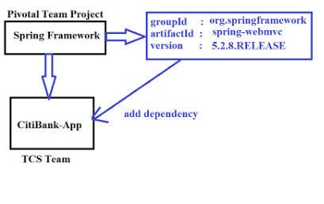

Pic 2:

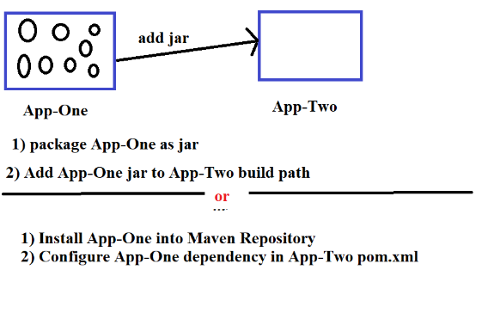

Pic 3:

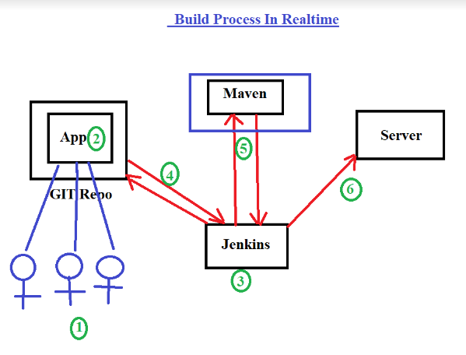

**Date: 11-Aug-2020 Topic: Exclusion & Maven Multi Module**

Today's session : Exclusions & Maven Multi Module

--------------------------------------------------------

-> install goal is used to install our application into maven local repository

-> Once we install application into local repository, then we can configure that application as a dependency in other applications

How to work with 3party jars in Maven?

--------------------------------------

-> If any jar files is not supported by Maven central repository then we need to install that 3rd party jar into maven local repository using 'maven install' goal.

-> We can install jar into maven local repository like below

> mvn install:instal-file -Dfile=name.jar

-DgroupId=com.ashokit

-DartifactId=pwd-utils

-Dversion=1.0

-Dpackaging=jar

Ex : (Executed below command from jar location)

-------------------------------------------------

> mvn install:install-file -Dfile=pwd-utils.jar

-DgroupId=com.ashokit -DartifactId=pwd-utils

-Dversion=1.0

-Dpackaging=jar

Note: With above command pwd-utils.jar file installed to maven local repository. We can use this as dependency in other projects.

Excluding sub dependencies from main dependency

-----------------------------------------------

-> When we add 'spring-context' dependency we are getting 'spring-aop' also by default. If we don't use 'spring-aop' in project then its waste of keeping 'spring-aop' dependency in build path. Un-necessariliy aop .class files will be loaded jvm metaspace (memory will be wasted).

-> To avoid that problem, we can exclude 'spring-aop' like below

<dependencies>

<dependency>

<groupId>org.springframework</groupId>

<artifactId>spring-context</artifactId>

<version>5.2.8.RELEASE</version>

<exclusions>

<exclusion>

<groupId>org.springframework</groupId>

<artifactId>spring-aop</artifactId>

</exclusion>

</exclusions>

</dependency>

</dependencies>

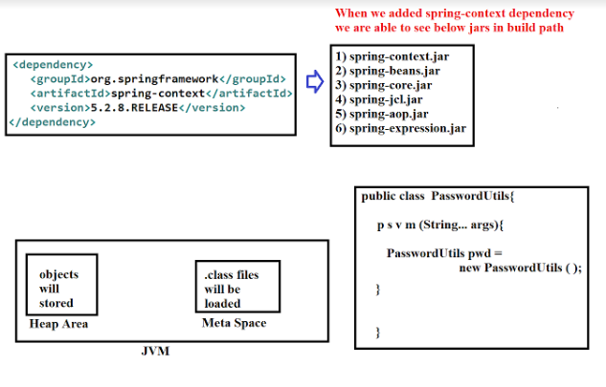

**Date: 12-Aug-2020 Topic: Maven Multi Module project & Maven scopes**

Today's session : maven multi module project

Today's session : maven multi module project

----------------------------------------------------

-> One application we can install into maven repository using mvn install goal.

-> One Jar file we can install into maven repository using mvn install:install-file

-> When we add dependency maven will take care of transitive dependency management.

-> If we don't want to use any sub dependency then we can exclude it by using <exclusion> command.

-> If we exclude unwanted dependencies from pom.xml, we can save MetaSpace memory.

Note: By Using Maven we can't identify which dependencies are not using in project which are declared in pom.xml file. Manually we need to vefiry which is getting used and which is not getting used.

Maven Multi Module Project

---------------------------

-> In our application several modules will be available

-> Our application will be developed in layered architecture fashion

-> For Every Layer we can create module in project

Steps to Create Maven Multi Module project

-------------------------------------------

1) Create Maven Project as Parent By selecting Packaging type as 'pom'

-> Right click on 'Parent" Project and select 'Maven Module' and create it.

Note: After creating module we can below changes in pom.xml files

1) In parent pom, child module name will be added

2) In child pom, parent pom dependent details will be added

-> When we compile parent project pom, it will complile child module pom files also.

-> When we add dependency we can see <scope> tag after <version> tag in dependency.

-> <scope> tag represents visibility of the dependency

Below are the maven scopes

---------------------------

1) compile scope

2) provide scope

3) runtime scope

4) test scope

5) system scope

6) import scope

7) transitivity resolution

-> compile is the default maven scope. The dependency with scope needed to build, test and run the project

**Date: 15-Aug-2020 Topic: Version Control Softwares GIT & Git Hub Intro**

Today's session : Version Control Softwares

---------------------------------------------------

What is Version Control Software and Why We need it?

----------------------------------------------------

-> A project development will happen with several team members

-> All project development team members may not be available in same location.

-> If development is happening from multiple locations then how to integrate code ?

Ex: Hyd team, chennai team, pune team etc...

**** Code Integration is the first problem ****

**** Monitored Access is the second problem ****

-> To avoid these 2 problems, Version Control Softwares came into picture

-> If we use version control softwares in our project they will take care of code integration and code monitoring.

-> Version Control Softwares are also called as Software Configuration Management sofwares.

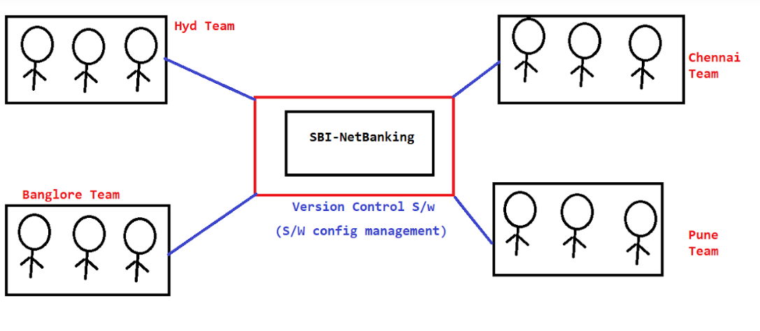

What are the version control softwares avialable?

--------------------------------------------------

IBM Clear case

SVN (Subversion)

GIT HUB

BitBucket etc.....

Note: GIT and BitBucket having lot of demand in market. Some legacy projects are still using SVN.

Version Control Terminology

---------------------------

Repository : It is the place where we will store our source code

Repository ID / Commit id: When we add new file/modified existing file then one commit id will be generated. Commit id wil be used for tracing purpose.

Clone : Taking the entire project from repository to local system.

Commit / Check-in : To push changes to repository

Update/Pull : Taking latest changes committed by team members.

Revert : Removing committed changes from Repository

logs : Checking commit history

Working with GIT (Environment setup

-----------------------------------

-> Create Account in (github.com)

-> Install GIT cient software

(<https://git-scm.com/downloads>)

**Date: 16-Aug-2020 Topic: GIT setup**

-> For every project one GIT repository will be created by GIT Admin in GIT HUB.

-> GIT Admin will provide repository access for all project team members

Note: Every Team member will have a GIT account (Once you join in project, they will create GIT account for you and they will share credentials with you)

Note: You Should not share your GIT credentials with anyone (It should be confidentials).

-> Being a team member we will install GIT client software in our machine and we will perform GIT operations in Project Repository with client software.

Note: Installing GIT client is not mandatory. We can perform GIT operations from IDE (Eclipse, STS and IntelliJ) also.

**Date: 17-Aug-2020 Topic: GIT repositories & Working With Git Bash**

Today's session : GIT Repositories

---------------------------------------------------------

-> For project we will create one repository in Git Hub

-> Git Hub will maintain our repositories in centralized location

-> We will use git client software to communicate with git hub repository

-> We can use several clients to communicate with Git Hub repository

1) Git Bash

2) Git Gui

3) Tortoise Git

4) Source Tree

5) IDE (Eclipse, STS, IntelliJ)

Create Repository in Git Hub

----------------------------

-> We can create 2 types of repositories in Git Hub

1) Public Repository

-> Anybody can see but we choose who can commit

2) Private Repository

-> We will decide who can see and commit

-> Once repository got created, it will generate repo URL for our repository like below

https://github.com/Java-Project-02/11-SBI-App.git

Note: Git admin will share this repo url with all team members. After getting this URL team members will perform operations using Git clients.

Who will create Git Repository?

-------------------------------

Project team member will send a request to Git admin team through email for creating repository then they will create repository and they will share repository URL.

From : ashok@abc.com

to : gitadmin@abc.com

cc : ourmanager-email-id

Subject: Git repository creation request

Body :

Hi Team,

Greetings for the day..!!

We are starting new project from tomorrow(18-Aug-2020) so please create GIT repository for the same with below details

Repository Name : SBI-App

@Manager-Name : Please approve this request.

Thanks,

Ashok.

-----------------------------------------------------------

-> Once we got repository url, we need to perform git operations using git client softwares.

Working with GIT Bash

---------------------

-> Download and install Git client software

-> After installing git client, right click on Mouse and select Git Bash Here -> It will open Git Bash cmd

Git Bash Commands

-----------------

git help : It provides common git commands (frequently used)

git help <cmdname> : Opens documentation of given command

git init : It is used to initialize our folder as git folder

configuring Uname and Email in Git Bash

---------------------------------------

git config --gloabl user.name "Ashok"